Task: Establish a new directory, populate it with script files, initiate an empty repository on GitHub, convert the local directory into a Git repository, and link it to GitHub for pushing the code into the repository.Perform merge, rebase, stash commands in following github repo.

Step 1: Create a EC2 instance and connect it to the instance
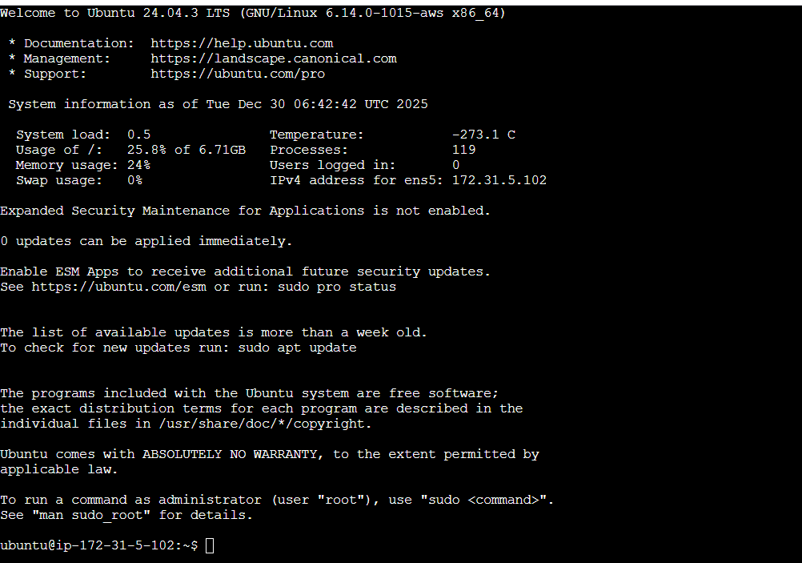

Step 2: Create a new directory
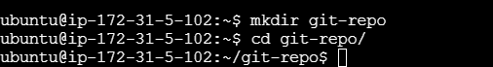

Step 3: Initiated an empty repository on GitHub “github-task”
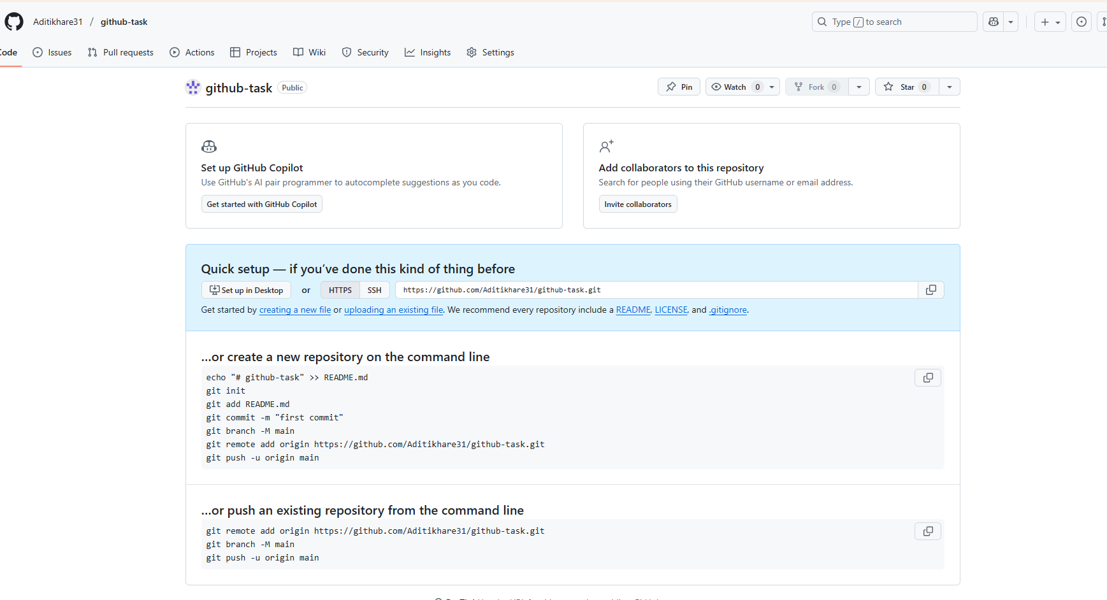

Step 4: Create a script file
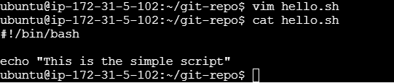

Step 5: Initialize the git repo using “git init” command and move the file to the from working directory to staging area
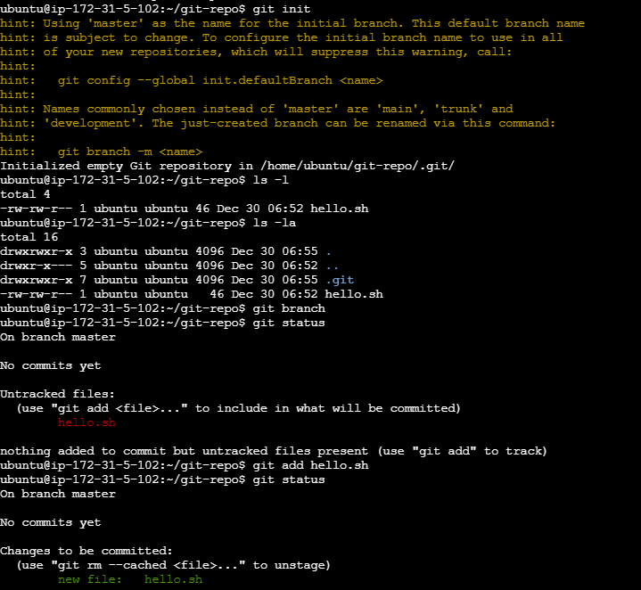

Step 6: Add files and make a first commit
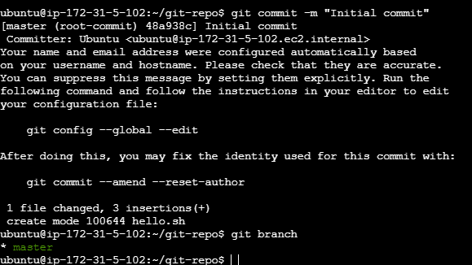

Step 7: Create a branch and modified the file
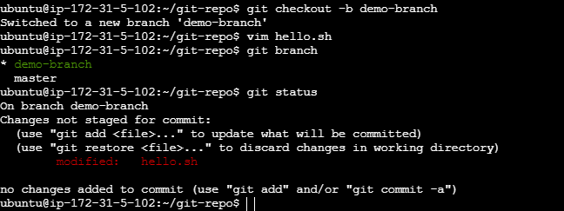
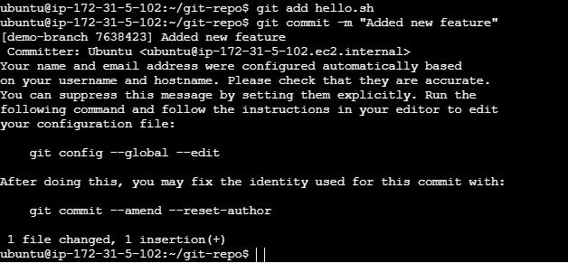
Step 8: Merge the branch into master branch
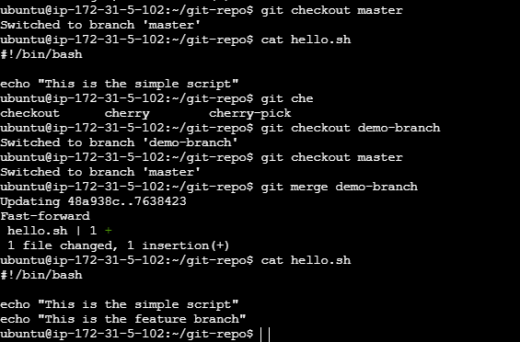

Step 9: Link the local repository to github and push
Note- I have already performed git remote add origin command that’s why it is giving remote origin already exists.
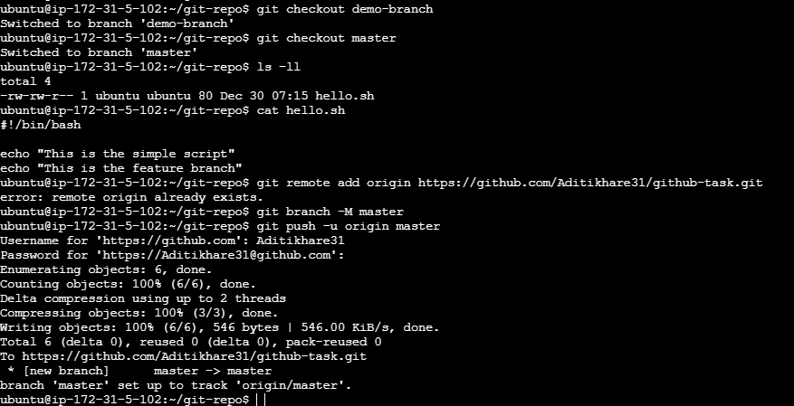
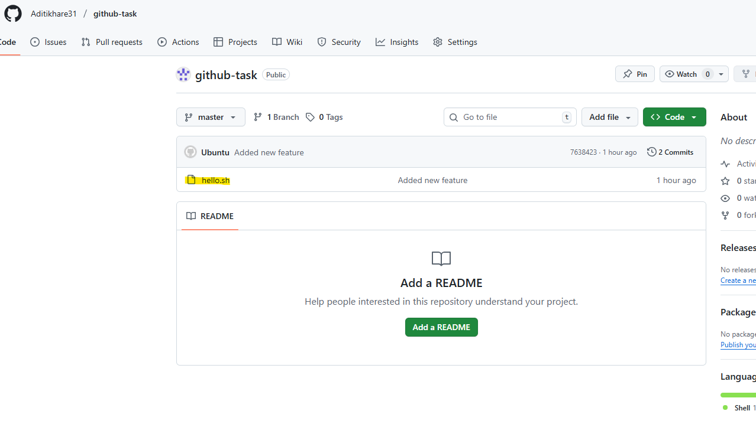

Step 10: Perform rebase, stash commands
Rebase
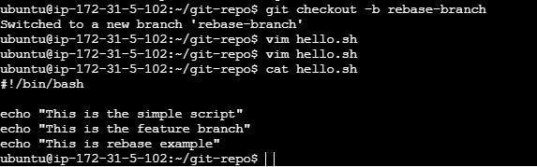

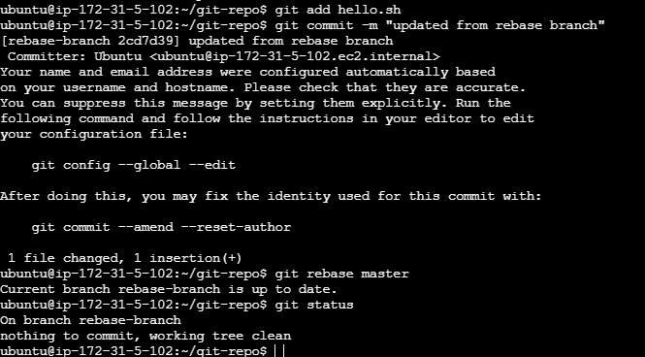

Stash
